**Name: VYSHNAVI BABU S**

**Roll No: 55**

**Batch: B**

**Date: 04-04-2022**

**NETWORKING & SYSTEM ADMINISTRATION LAB**

**Experiment No.: 5**

**Aim**

Familiarization of basic Linux commands.

**Procedure**

1. **cp a.txt b.txt :** It copy the contents of **1st file** to the **2nd file**.

**Syntax : cp Src_file Dest_file**

**Output :**

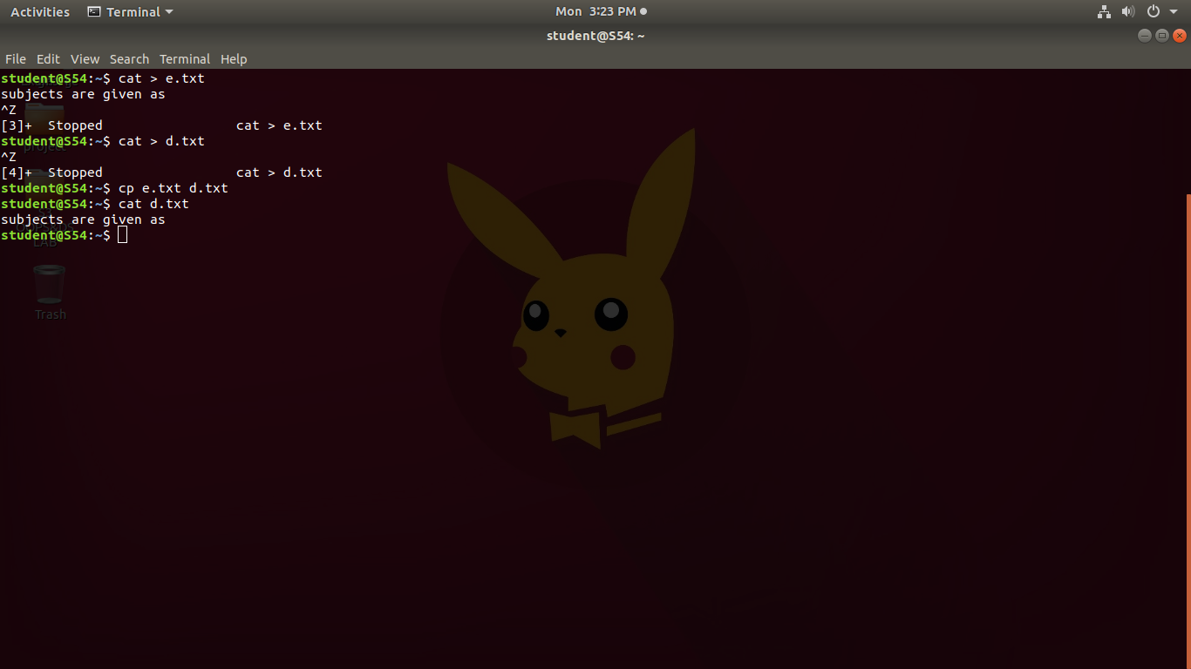

1. **cp -r Pictures vysh : cp**copies all files of the source directory to the destination directory, creating any files or directories needed.

**Syntax : cp -R Src_directory Dest_directory**

**Output :**

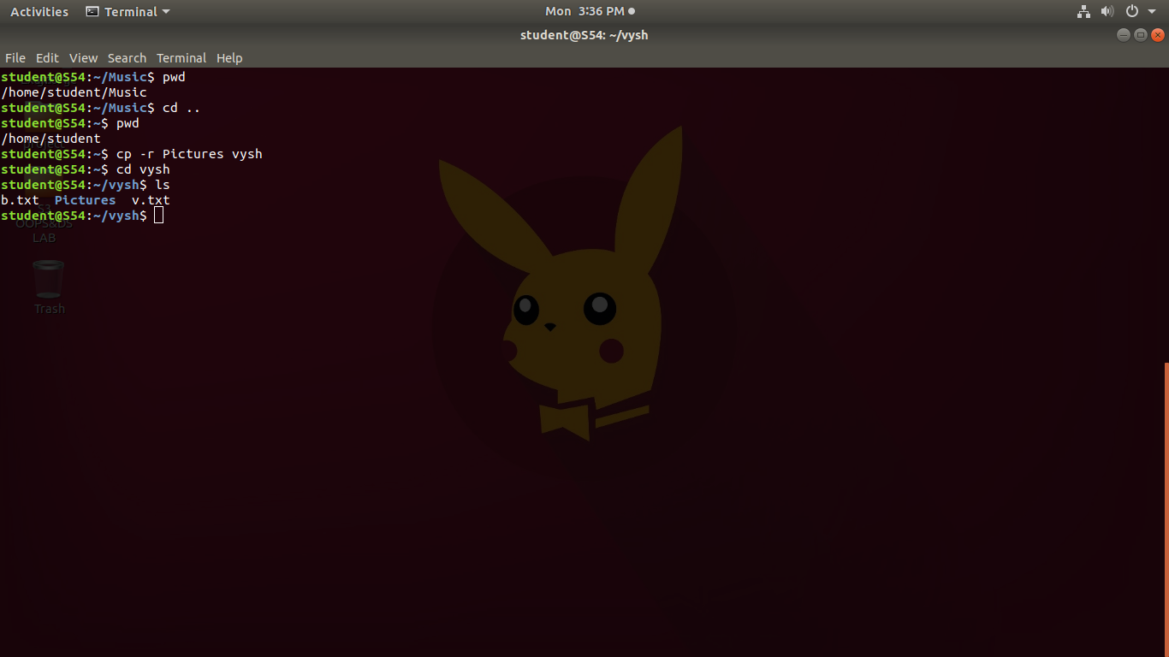

1. **cp -i h.txt k.txt :** With this option system first warns the user before overwriting the destination file. **cp** prompts for a response, if you press **y** then it overwrites the file and with any other option leave it uncopied.

**Syntax : $ cp -i a.txt b.txt**

**cp: overwrite 'b.txt'? y**

**Output :**

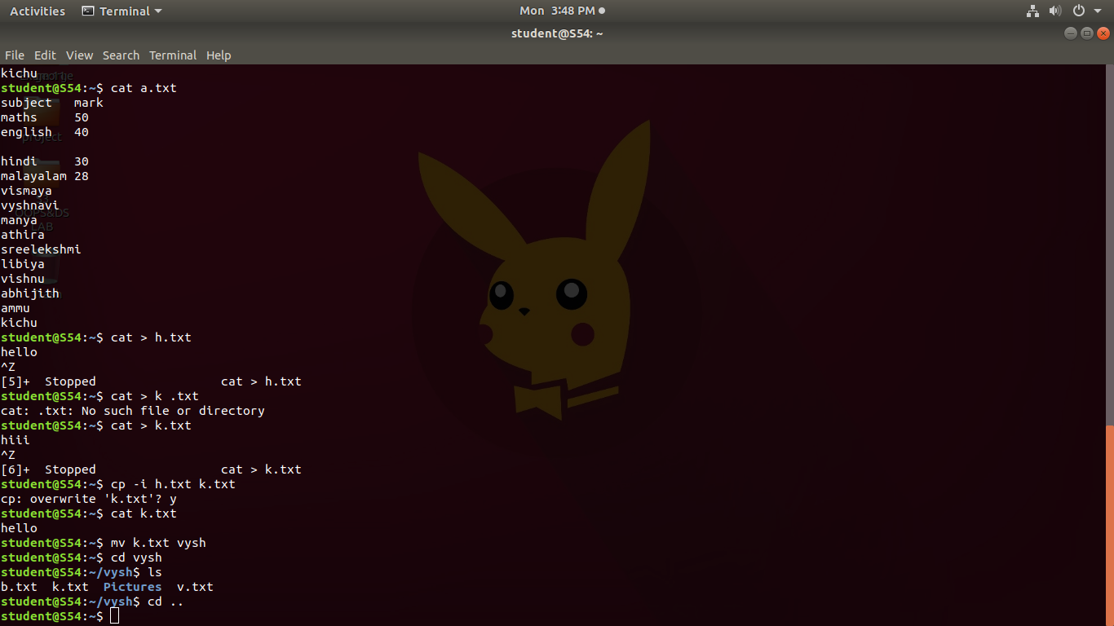

**4.mv k.txt vysh : to move content in source file to destination file.**

**Syntax : mv source destination**

**Output :**



1. **mv -i a.txt c.txt :** option makes the command ask the user for confirmation before moving a file that would overwrite an existing file, you have to press **y** for confirm moving, any other key leaves the file as it is.

**Syntax : mv -i source destination**

**Output :**

